Notification regarding the Board of Management’s review of the Child Safeguarding Statement

To:_St George’s NS community_______________________________

The Management of _St George’s NS wishes to inform you that:

• The Board of Management’s annual review of the school’s Child Safeguarding Statement was completed at the Board meeting of 28 September 2023.

• This review was conducted in accordance with the “Checklist for Review of the Child Safeguarding Statement” published on the gov.ie website

Signed _D.Pierpoint____________________________________ Date_28/09/’23 __________

Chairperson, Board of Management

Signed _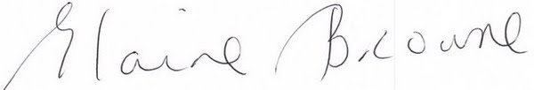____________________________________ Date _28/09/’23

Principal/Secretary to the Board of Management

